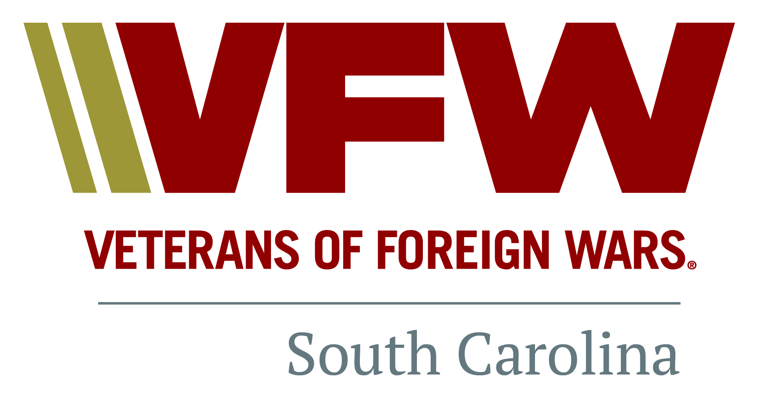

**2022-2023 (1 July 2022- 30 June 2023)**

**COMMUNITY SERVICE REPORT FORM** **FOR INDIVIDUAL COMRADES**

**(Including Post Auxiliaries)**

**Post / Auxiliary Number: ________ District Number ________**

**DATE OF ACTIVITY ___________**

**SELECT A PROGRAM (Circle your choice)** (See definitions of each category below):

**Community Service Americanism/ Citizen Education Youth Activities Safety Veterans and Military Support Voice of Democracy Patriots Pen Teacher of Year/ Scouting Program**

**CUMULATIVE (Total) HOURS______ TOTAL MILES____________**

**TOTAL MEMBERS______________ DOLLARS SPENT or DONATED ___________**

(Example: Cumulative Hours- **12 Total Hours,** 4 Members (each performed 3 hours service)

((Safety example: Safety brief at meeting lasted 2 minutes. 22 comrades attended. Total is 44 minutes.

Divide 40 mins by 60 mins to get the decimal and enter .67 in total hours. (44/60 = .67 hours))

**DESCRIBE the activity & how it meets the criteria for the category from the definitions below (use other side for more space if necessary)** ________________________________________________________________________________________________________________________________________________________________________________________________________________________________________________________________________________________________________________________________________________________________________

***This form is for individual comrades to provide their contributions for Community Service to their Post Commander. The Commander’s designated reporting official will consolidate these reports monthly and submit monthly Community Service Activity reports using the report form at:*** [**https://vfwsc.org**](https://vfwsc.org)

**Categories of Community Service/Definitions:**

**COMMUNITY SERVICE** includes any activities within your community which help to benefit the community, church, school, parks, recycling, neighborhood cleanings, etc.

**AID TO OTHERS** is self-explanatory. Taking a hot meal to a veteran who can't get out is an example.

**AMERICANISM/CITIZEN EDUCATION** - teach someone about flag etiquette, military service, etc.

**YOUTH PROGRAMS** include the annual Voice of Democracy, Patriot's Pen, Scout of the Year Program, etc.

**YOUTH ACTIVITIES** - Posts and Auxiliaries are encouraged to provide youth programs within the community such as Athletics, Scouting, School Assemblies, Veterans in the classroom, Contests, Recognition, etc.

**SAFETY** - Pedestrian, Drug Awareness, Recreational, Highway, Home/Fire, etc.

**MILITARY SERVICE** - Any support given to a unit, an individual family member, ceremonies, welcome home, uplink, Unmet Needs, USO, etc.